**OPTIMIZING USER, GR0UP,AND ROLE MANAGEMENT WITH ACCESS CONTROL AND WORKFLOWS**

**Team ID:NM2025TMID13793**

**Team Size :4**

**Team Leader : LOSHINI R**

**Team Member: KALIDASS E**

**Team Member: HAMEETH FARHAAN F**

**Team Member: VISHAL S**

**ProblemStatement:**

**Organizations often face inefficiencies in managing user access, roles, and permissions, especially when scaling. Without a centralized and dynamic system, there's a high risk of unauthorized access, manual errors, and compliance issues. Our project aims to address these challenges by designingasystemthatstreamlinesuser,group,androlemanagementwith integrated access control and approval workflows.**

**Objective:**

**Todevelop a secure, scalable, and automated systemthat allows administratorstoefficientlymanageusers,roles,andpermissions,along**

**withworkflowsthatenforceaccesscontrolpoliciesacrosstheorganization.**

# Skills:

* **Role-BasedAccessControl(RBAC)**
* **User&GroupManagementSystems**
* **Backend Development (e.g., Node.js, Django, or Spring Boot)**
* **FrontendUI(e.g.,React,Angular)**
* **WorkflowAutomationTools**
* **DatabaseDesign(SQL/NoSQL)**
* **Authentication&Authorization(OAuth2,JWT)**
* **CloudPlatforms(e.g.,AWS,Azure,GCP)**

# TASKINITIATION:

**Startwithresearchandrequirementgathering.Definekey components like:**

* **Userregistration/authenticationmodule**
* **Role&permissionmatrix**
* **Accesscontrolrulesengine**
* **Approvalworkflowmodule**
* **Admindashboard**

## CreateUsers

* 1. Openservice now
  2. ClickonAll>>searchfor users
  3. SelectUsersundersystemsecurity
  4. Clickonnew
  5. Fill the followingdetailstocreatea newuser
  6. Clickonsubmit

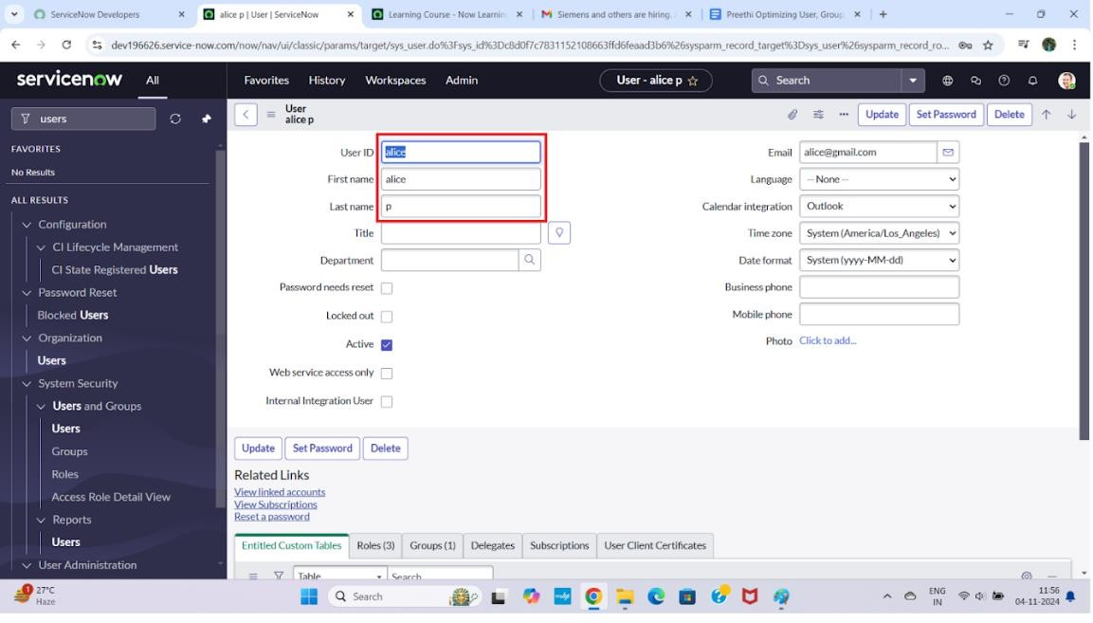

**Createonemoreuser:**

* 1. Createanotheruserwiththefollowingdetails
  2. Clickonsubmit

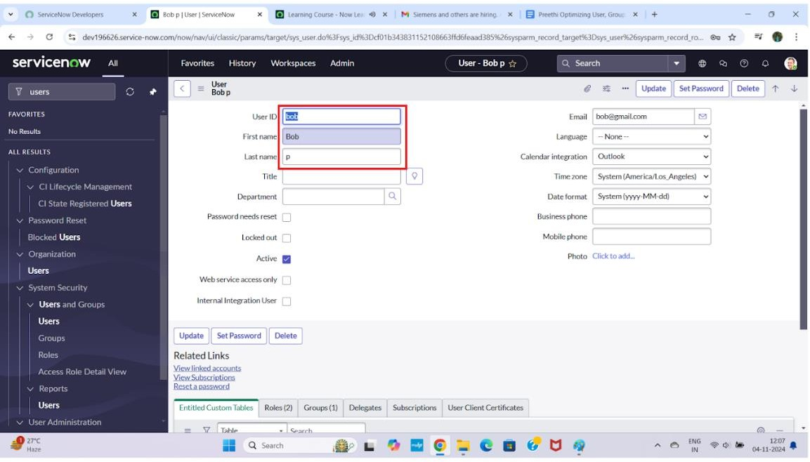

1.

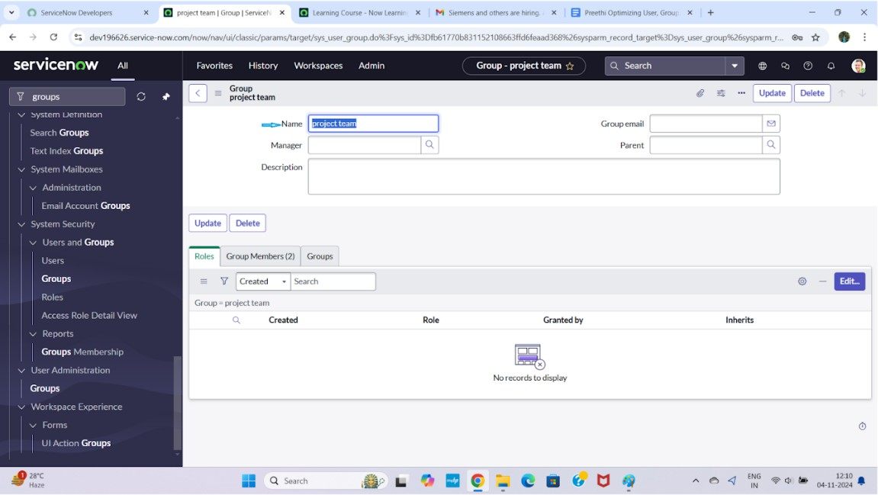

## CreateRoles

1. Openservicenow.
2. ClickonAll>>searchforroles
3. Selectrolesundersystemsecurity
4. Clickon new
5. Fillthefollowingdetailstocreateanewrole
6. Clickon submit

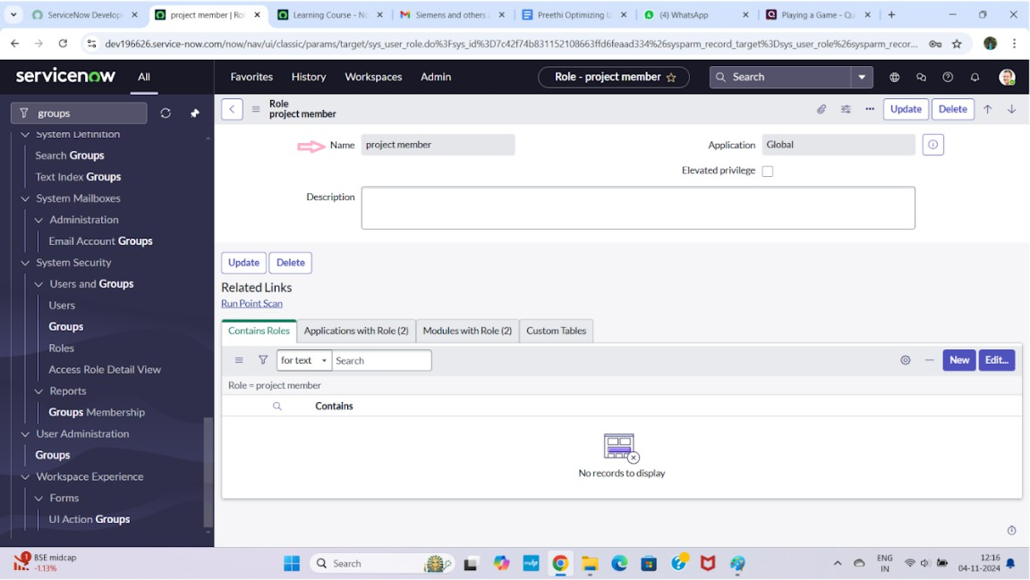

## Createonemorerole:

1. Createanotherrolewiththefollowingdetails:Teammember
2. Clickon submit

## CreateTable

* 1. Openservicenow.
  2. ClickonAll>>searchfortables
  3. Selecttablesundersystemdefinition
  4. Clickon new
  5. Fillthefollowingdetailstocreateanewtable Label : project table

ChecktheboxesCreatemodule&Createmobilemodule

* 1. Undernewmenuname:projecttable
  2. Undertablecolumnsgivethecolumns

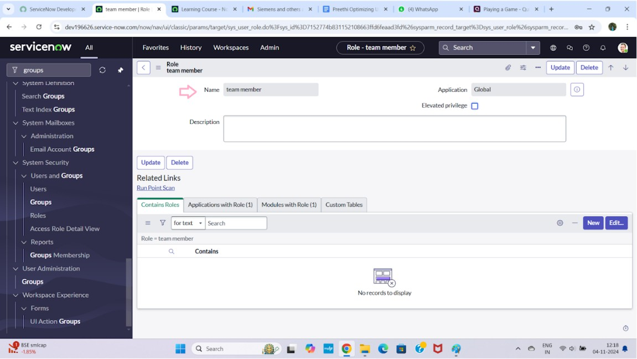

* 1. Clickon submit

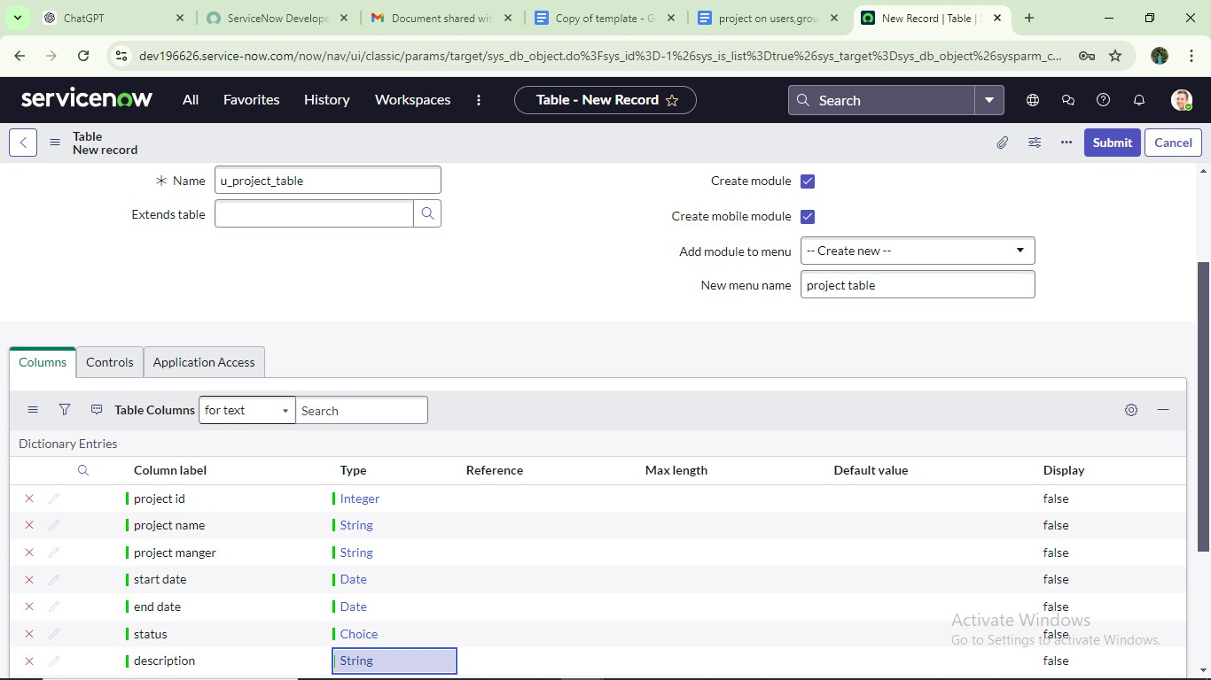

## Createonemoretable:

* 1. Createanothertableas:tasktable2andfillwithfollowing details.
  2. Clickonsubmit.

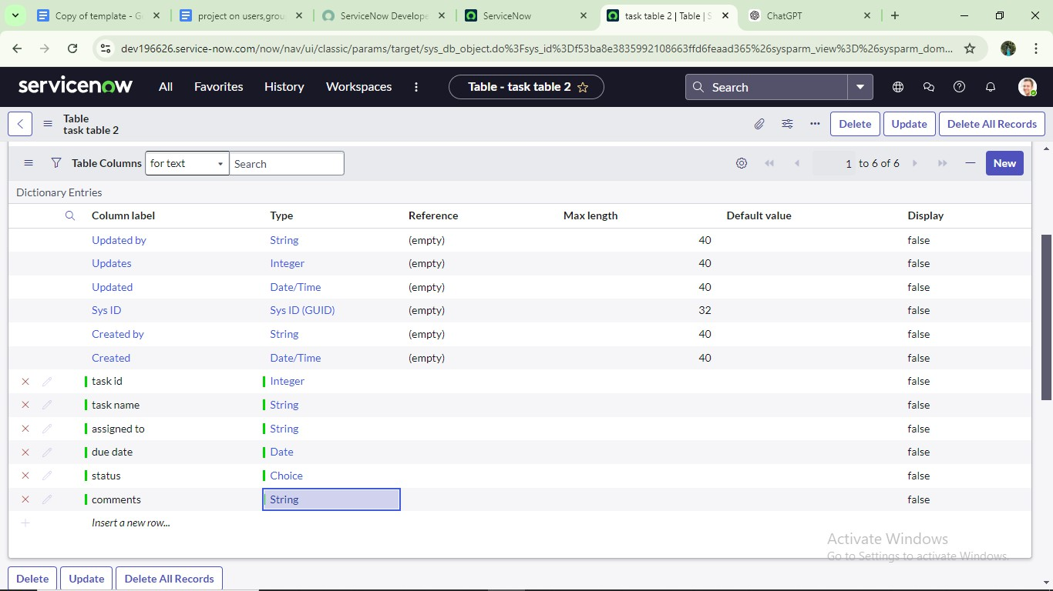

## Assignuserstoprojectteamgroup

1. Openservicenow.
2. ClickonAll>>searchforgroups
3. Selecttablesundersystemdefinition
4. Selecttheprojectteamgroup
5. Undergroupmembers
6. Clickon edit
7. Selectalicepandbobpandsave

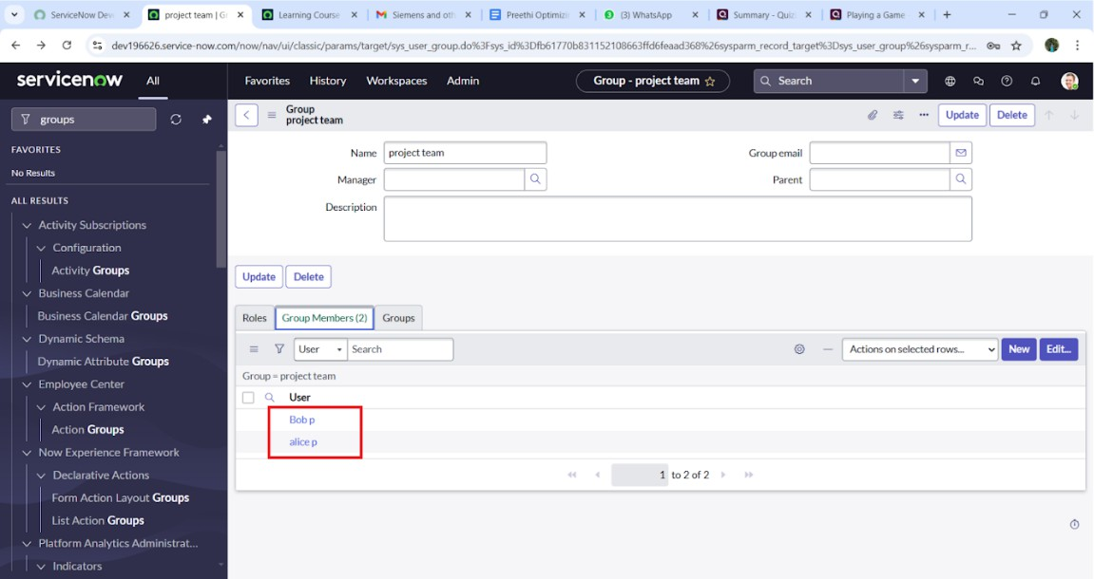

## Assignrolestoaliceuse

* 1. Openservicenow.ClickonAll>>searchforuser
  2. Selecttablesundersystemdefinition
  3. Selecttheprojectmanageruser
  4. Underprojectmanager
  5. Clickon edit
  6. Selectprojectmemberandsave
  7. clickoneditaddu_project_tableroleandu_task_tablerole
  8. clickonsaveandupdatetheform.

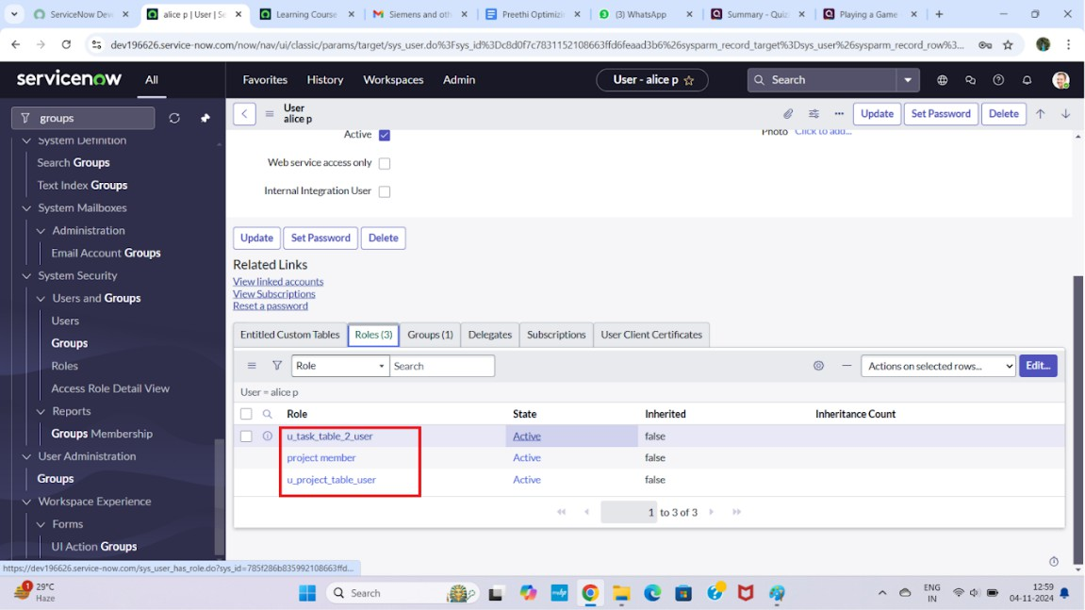

## Assignrolestobobuser

1. OpenServiceNow.ClickonAll>>searchforuser
2. Selecttablesundersystemdefinition
3. Selectthebobpuser
4. Underteammember
5. Clickon edit
6. Selectteammemberandgivetableroleandsave
7. ClickonprofileiconImpersonateusertobob
8. Wecanseethetasktable2.

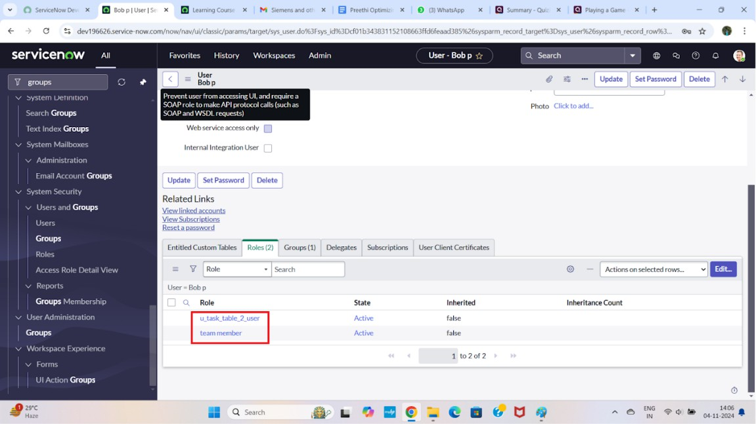

## Assigntableaccesstoapplication

* 1. whilecreatingatableitautomaticallycreateaapplicationandmoduleforthattable
  2. Gotoapplicationnavigatorsearchforsearchprojecttableapplication
  3. Clickoneditmodule
  4. Giveprojectmemberrolestothatapplication
  5. Searchfortasktable2andclickoneditapplication.
  6. Givetheprojectmemberandteammemberrolefortasktable2application

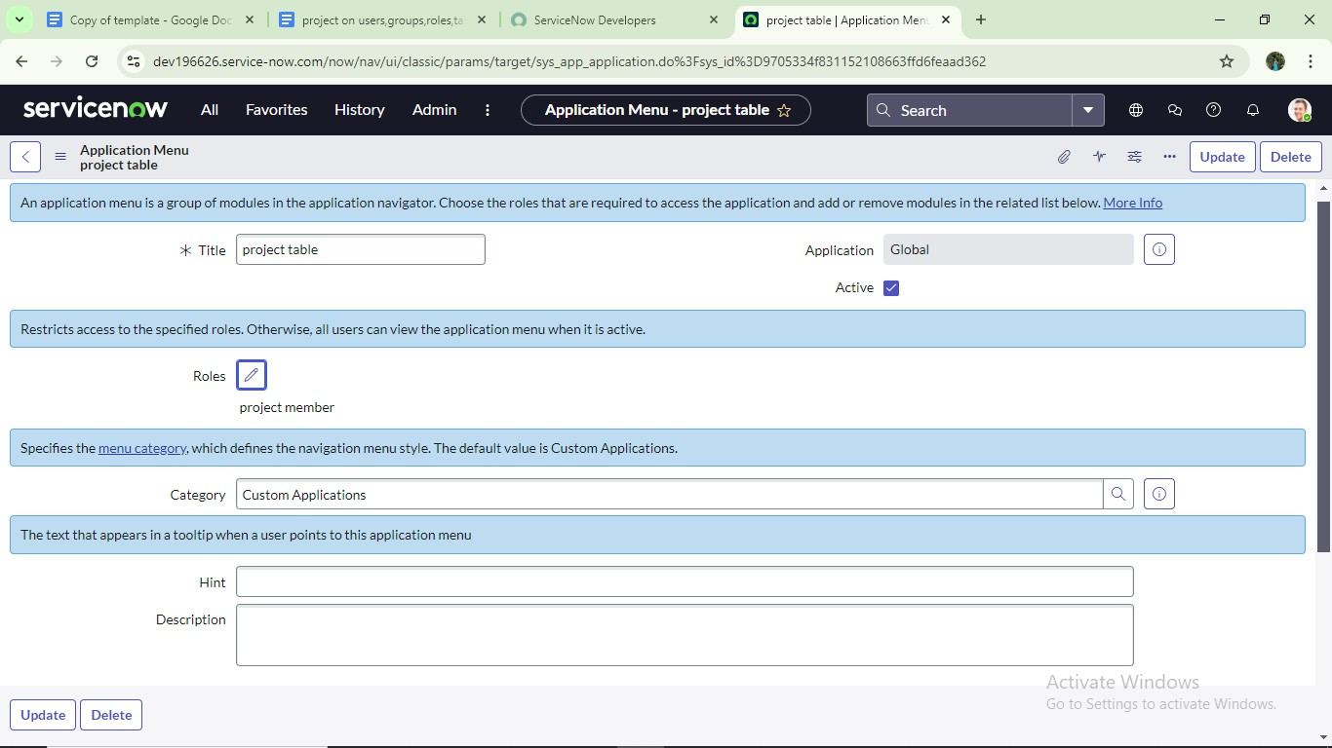

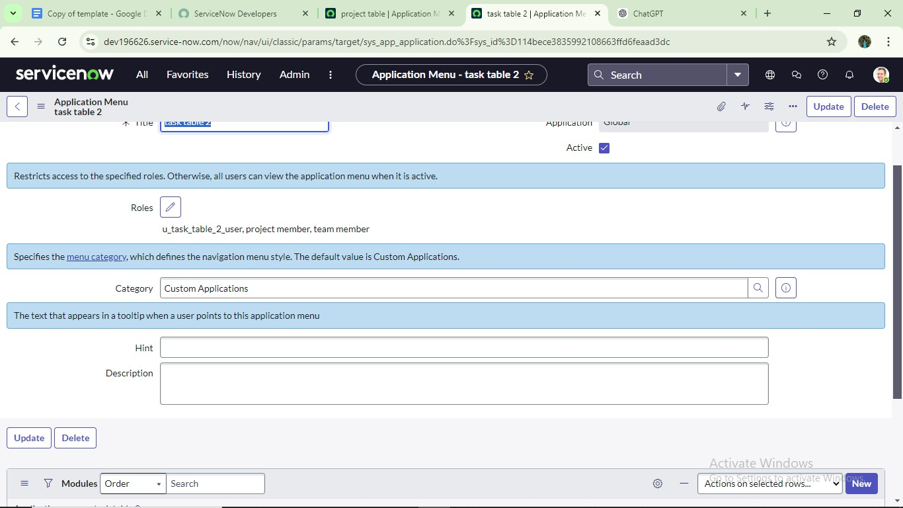

**Conclusion:**

Thisscenariohighlightsastructuredapproachtoprojectmanagement,

showcasingtherolesofAliceandBobwithinadefinedworkflow.WithAlice's oversight and Bob's execution, the team effectively collaboratesto ensure project success. The useof tables organizes key information,facilitatingeasy

trackingofprojects,tasks,andprogressupdates.Overall,thissystempromotes accountability, enhances communication, and leads to the successful

completionofprojects.